**UBER IDA PRA RENAULT (12/04)**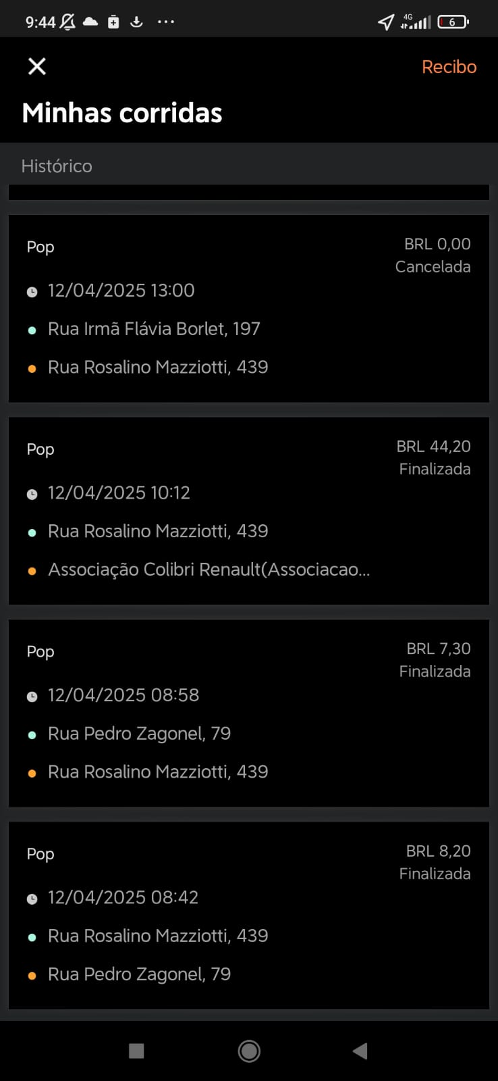

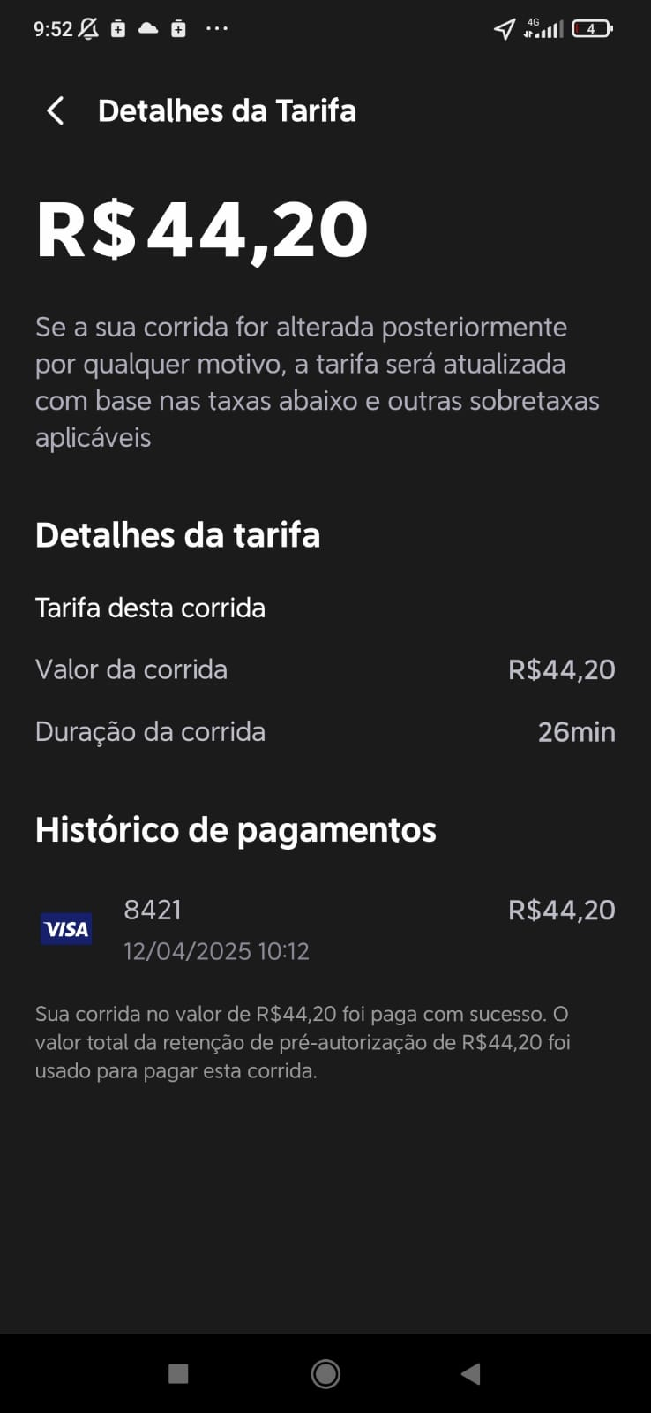

**UBER IDA PRA DENTAL COM CAMERA (14/04)**

